Versions:

Date | Version | Author | Comments
12.11.2020 | 1.0.0.0 | Stancu Gabriel - Iulian | The initial analysis and design requirements for the project.
13.11.2020 | 2.0.0.0 | Stancu Gabriel – Iulian | Added the diagrams for section 9.
14.01.2020 | 3.0.0.0 | Stancu Gabriel – Iulian | Updated features list, introduced bugs list

Analisys&Design for Markets Shark

Content:
- General Presentation

- Theoretical Fundamentals

- IT Technology (which will be implemented)

- Functionalities

- Actors and related access rights

- Use Case Diagrams

- System Architecture

- Design (UML Diagrams)

- Operation Mode (Operation Guide, including screen-shots)

- Portability

- Competing software

- Bug list

1. General Presentation

The project presented in this document is a web application that compares various hardware components, like computers, laptops etc. from different popular websites based on the criteria inserted by the user in the graphical user interface. The project achieves this by web-scrapping the popular vendors’ websites and retrieving the collected information in our website’s graphical user interface. Our project will not contain a physical storage for the searched products, as we only retrieve information from vendors’ websites and display it for the user, eventually allowing the user to buy directly from our website. This way, our website acts as an intermediate between the user (the buyer) and the vendors.
The project will be split into two parts: the server side (the API) and the client side. For the first part, C# will be used, while for the client side Angular will be used, which implies HTML, CSS and Typescript.

- Theoretical Fundamentals

The application is a website that collects information from various well-known hardware components vendors. In order to achieve this, the priciple of web-scrapping is used: based on the filtering criteria taken from the user input, searching links will be generated in the format of each vendor’s website. Then, using Regex pattern matching, the data will be collected from the HTML content of the page and objects containing the appropriate information will be created in memory, which will then be displayed graphically in the user interface. The user can then go to the vendor’s website to see the product more detailed or even buy it from there, or buy it straight from our website. The payment is registered in our account, which will then be redirected to the original vendor.
For faster data loading and more responsiveness, we will make use of the Angular’s modular development strategy, which will later enable lazy-loading, i.e. loading each module only when it is needed, instead of loading them all at the beginning of the session. Angular uses three main components / languages: HTML for the general layout of each component, CSS for styling it, and Typescript, for easier OOP maping between the component and the code it needs to display data, received from the http requests sent to the server.

- IT Technology

The application will be written in C# for the backend, Angular for the frontend and SQLite for the database structure.
For the backend, i.e. the server side, the used framework is .NET Core 3.1, which is cross-platform. The application will then be published to Azure, which will host our website. The structure of the project will be written in MVC pattern style, having :
- API as the view component : contains the hitpoints of our application, i.e. the parts of the interface the user can interract with (actually where the http requests sent by the user from the client user interface reach our API) : the interface for inserting filtering criteria, the option to buy products, logging in / out etc. ;
- Core as the model component : contains classes that reflect entities from the database, interfaces to be implemented in the Infrastructure component etc. ;
- The Infrastructure as the controller component : connects the other two parts, containing most of our application’s logic : the web-scrapping functionality, the Regex pattern matching etc. For easier communication between these components, the .NET Core 3.1 framework provides already-implemented components for the Service pattern, and also a dependency injection container, used for passing the services across the entire application.
For retrieving the required information from the vendors’ websites, the principle of web-scrapping is used : we build searching link, then get the content of the results pages, match it with Regex in order to collect the relevant data for building our objects and finally displaying them in the user interface. The scrapping criteria classes will be stored in the Core, while the actual scrappers will be stored in the Infrastructure component.
For the frontend, i.e. the client side, Angular is used, which uses concepts like modules, services and dependency injection (the last two are also heavily-used in .NET Core 3.1). The project will also be split into three components, which will all be contained by a main module, the App module :
- The Core module : contains singleton components, i.e. components that are always present in the user interface (i.e. the navigation bar of the website) ;
- The Features module : all the functionalities in the user interface ; each one will have its own module and routing (to enable lazy-loading) ;
- The Shared module : contains components that are available / could be used in more than just one part of the application, as the application scales up (for instance, the paging functionality), but also models used in the application architecture (the products, product brands etc.) ;
For the database, SQLite will be used due to the easy implementation and due to the small size of data that needs to be stored between application sessions, as most of the information is loaded dynamically after the user applies the filters for his searching.
For processing payments from the users, Stripe will be used.

- Functionalities

- Administrator: enable/disable vendor websites, test various errors, reload manually the products to be displayed
- Registered user: enter the application, sign up, login, change account information settings (e.g. the shipping address) browse for content (compare products), add products to chart, track previous acquisitions, track current acquisitions, buy, being redirected to vendor’s site
- Unregistered user: enter the application, browse for content (compare products etc.), create account, add products to chart.

- Actors and related access rights

This administrator is the person that manages the system. The administrator is the one responsible for maintenance of the website. He can enable/disable vendor websites, test various errors between server and client, update manually the list of collected products.
The registered user is the one that can perform the most tasks on the website. After signing in, he can browse for content, place orders, track the on-going orders, see the history of their orders placed through the website.
The unregistered user can only compare products from different vendors’ websites, but he cannot place orders and track them. For placing orders and track them through our website, the unregistered user needs to sign up. He can add products to chart.

- Use Case Diagrams

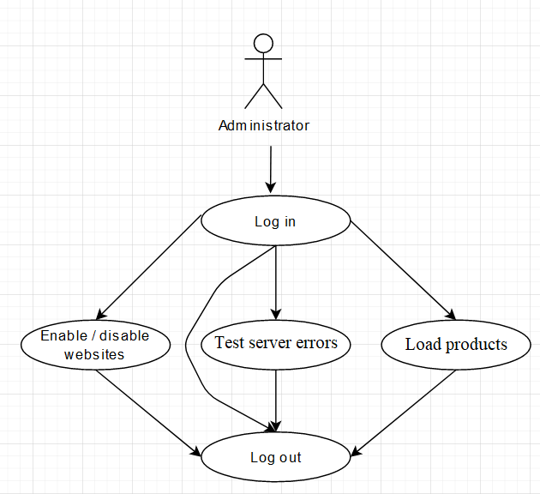

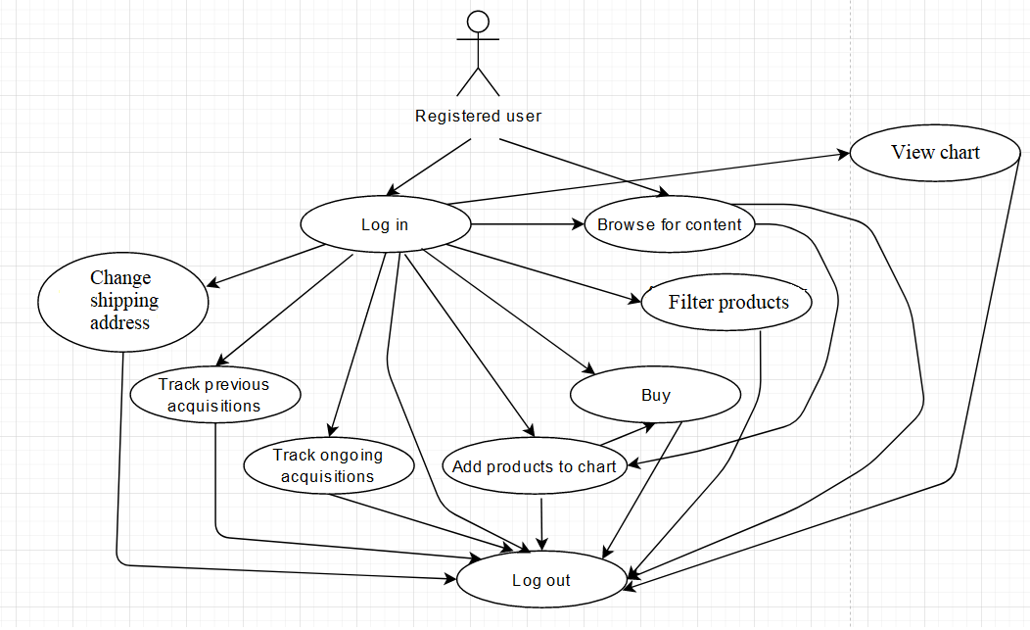
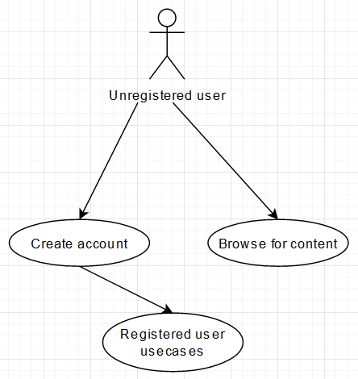

- System Architecture

- For the server side, the structure is the following one (based on the information from section 3):
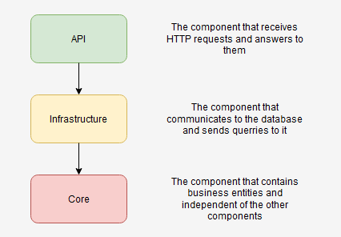

- For the client side, the structure is the following one (also based on the information from section 3):
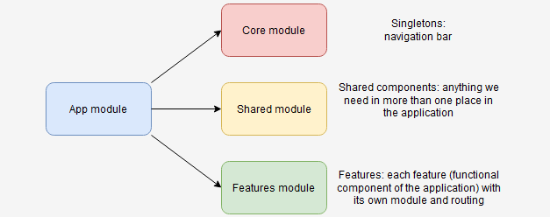

- Design (approx. 12 UML Diagrams!!!)

- Use Case Diagrams – see section 6

- System Architecture / General System Diagram & Flow Chart Diagrams (the main flow)
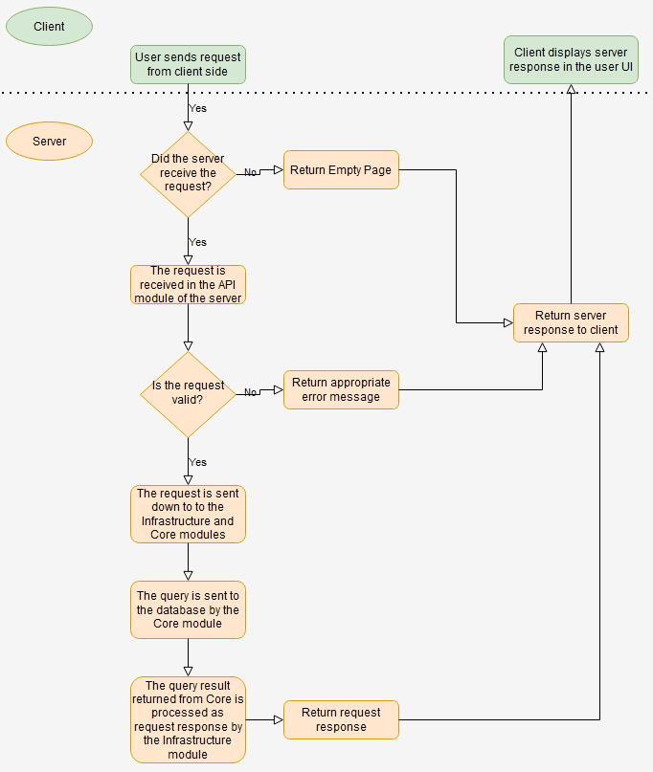

- Class Diagram

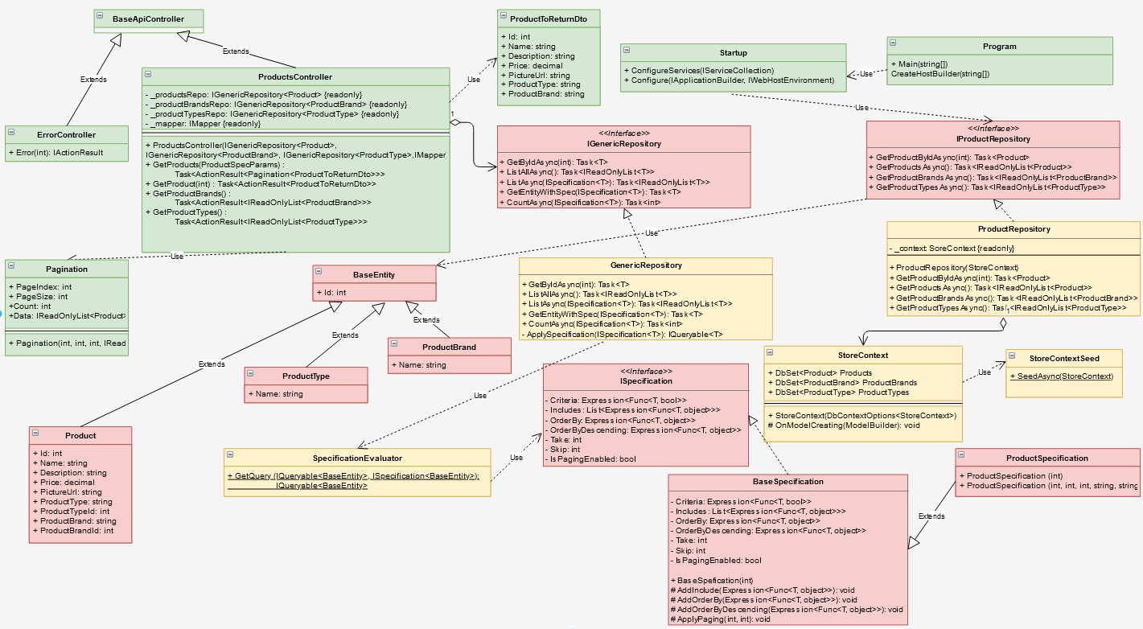

- Object Diagram

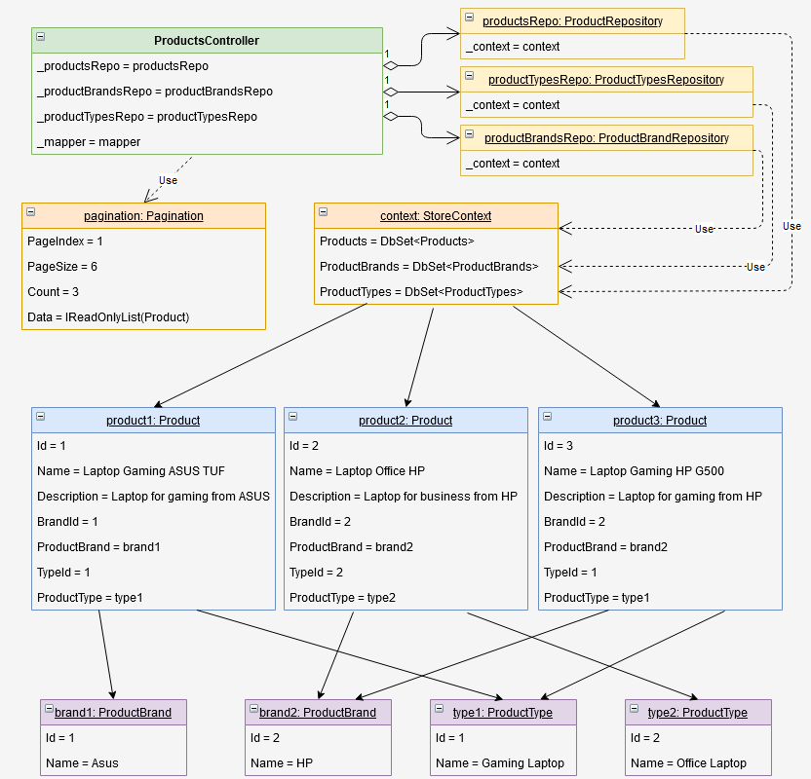

- Sequence Diagram

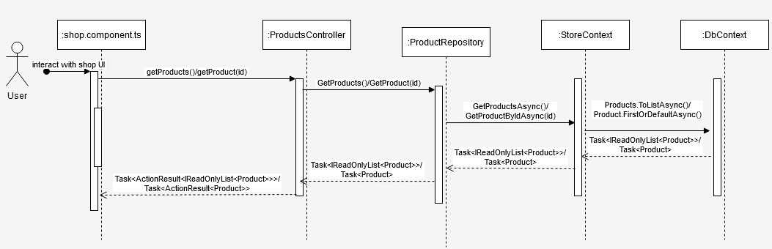

- Activity Diagram

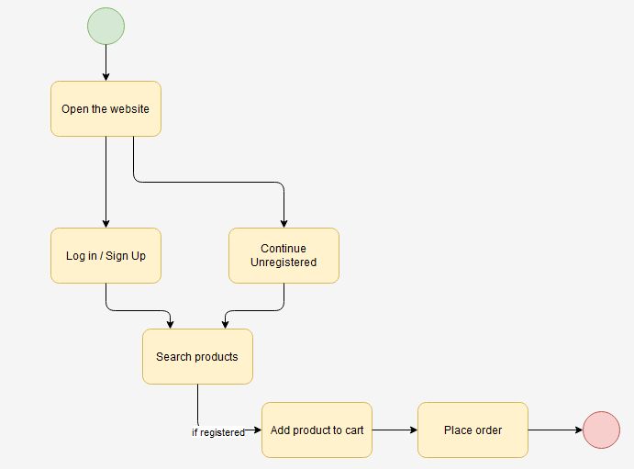

- State Transition Diagram
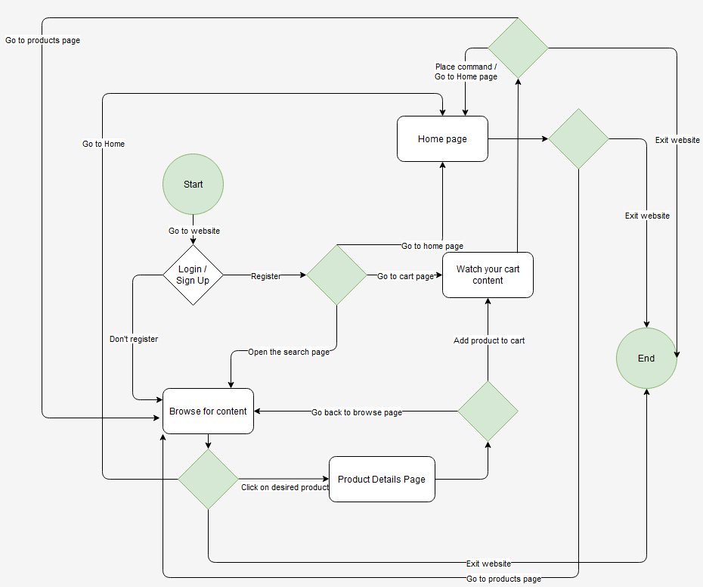

- Communication Diagram

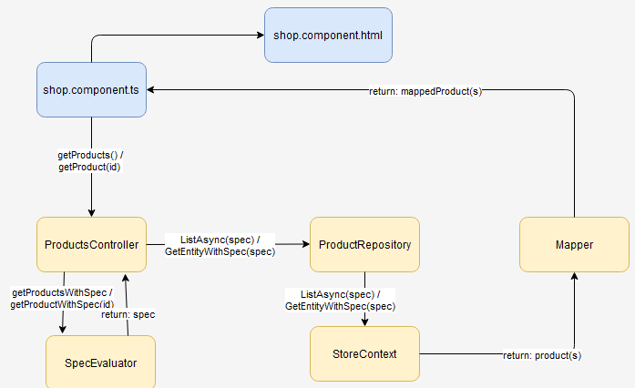

- Database Diagram

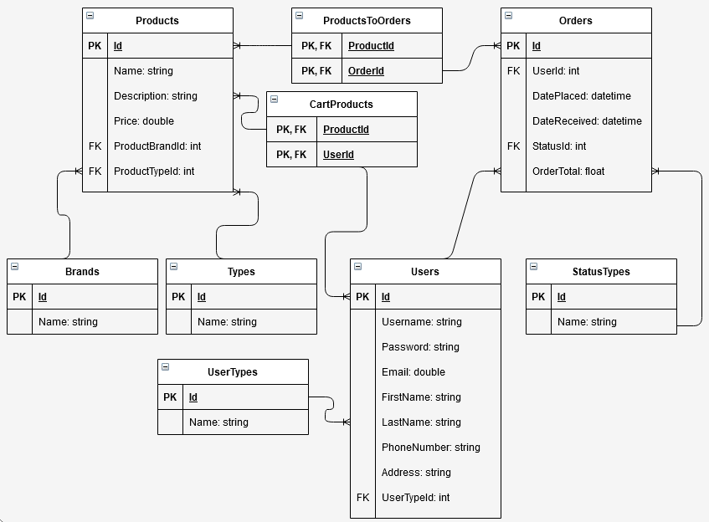

- Component Diagram

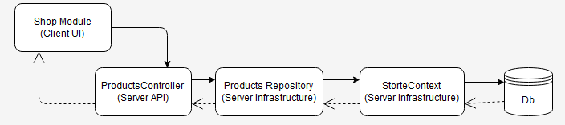

- Package Diagram

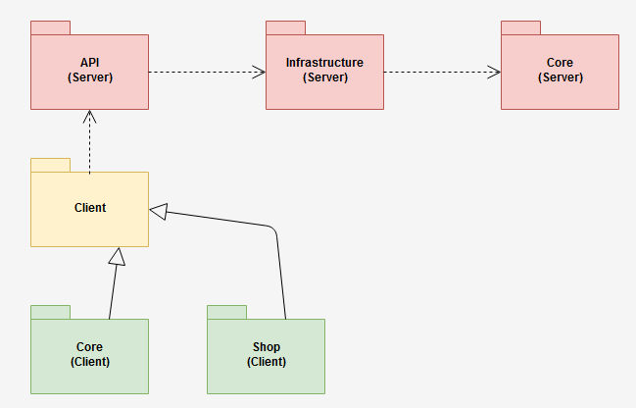

- Deployment Diagram

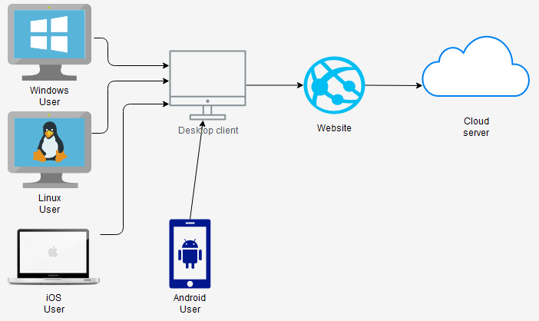

- Operation Mode (Interactivity presentation) + screen shots (UI design)
- The shop’s main interface:

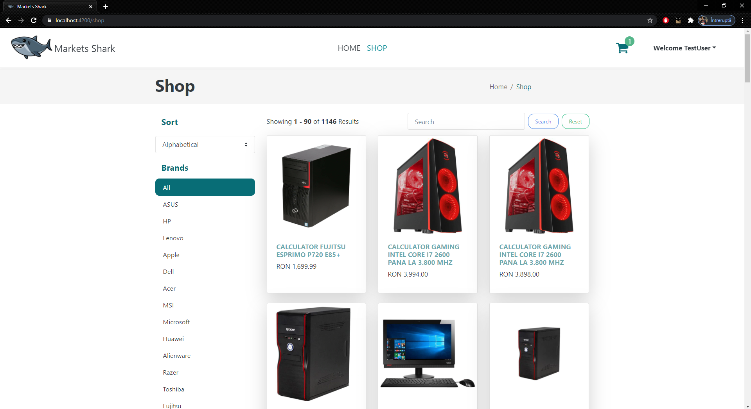

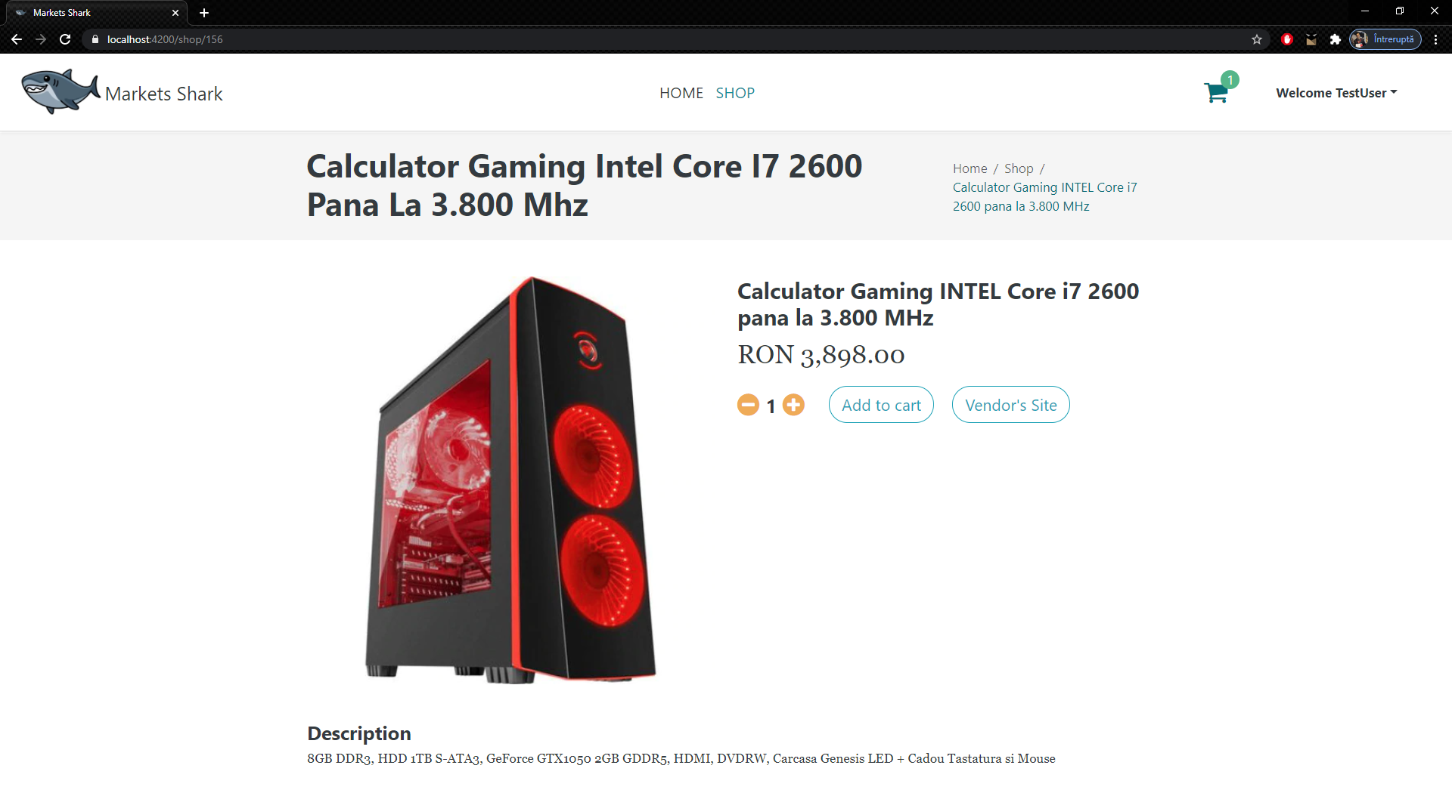
- The interface for each individual product:

- Portability

Since our application is a website made in .NET Core 3.1, it will be portable to the most used operating systems: Windows, iOS, Linux., and also because of the access to CLR which is provided to the .NET Core framework, it is also supported on the Android devices. The interface will be user-friendly, being built with some of the most well-known web design tools: HTML, CSS and Typescript. The hosting will be covered by Azure, so that high-speed access to the servers are provided for the users and the hosting aspect is passed to a specialized platform developed by Microsoft.

- Competing software

- compari.ro
- CPUBoss
- GPUBoss

- Bug-list

Crt.  No | Testing Scenario | Bug/Bugs | Bug Identification Date | Bug Fixing Date | Status  [Open/Closed]
1 | Logging in | User info not stored | 22.11.2020 | 22.11.2020 | Closed
2 | Signing up | User can sign up with existing email | 24.11.2020 | 24.11.2020 | Closed
3 | Displaying items | Product boxes with unequal sizes | 24.11.2020 | 24.11.2020 | Closed
4 | Sending requests to server | Bad responses from server | 28.11.2020 | 29.11.2020 | Closed
5 | Adding JWT tokens & Authentication Guards | Areas that should not be guarded by authentication were guarded | 20.12.2020 | 20.12.2020 | Closed
6 | Reloading page after adding products to chart | Products added to chart were removed after reloading the page | 22.12.2020 | 22.12.2020 | Closed
7 | Refreshing page on product details page | Product name would be incorrectly loaded after refresh | 23.12.2020 | 23.12.2020 | Closed
8 | Loading products with scraper | Scraper would bring weird characters instead of “ in products names | 28.12.2020 | 29.12.2020 | Closed
9 | Loading products from admin interface | Some corrupted products (gifts) would be loaded | 02.01.2021 | 03.01.2021 | Closed
10 | Reaching admin interface from shop | The admin interface could be reached without admin authentication | 06.01.2021 | 06.01.2021 | Closed
11 | Logging off and on with different user types (admin and registered user) | The last loaded interface was loaded although the user type has changed | 07.01.2021 | 08.01.2021 | Closed
12 | Changing website default colors | Some default colors of the websites could not be changed | 08.01.2021 | 09.01.2021 | Closed
13 | Making a payment | Stripe would register the payment in USD instead of RON | 10.01.2021 | 10.01.2021 | Closed
14 | Viewing orders | Previous orders would be loaded without product image | 12.01.2021 | 12.01.2021 | Closed
15 | Reloading the products | Targeting the vendors’ websites too frequently would return 501 response | 13.01.2020 | 14.01.2020 | Closed

